Excel Part 1 | Assignment

- What is the difference between 'Paste' and 'Paste Special' in Excel? Briefly explain with examples.

Ans : Difference between Paste and Paste Special in Excel

Feature | Paste | Paste Special
Meaning | Pastes everything exactly as copied | Lets you choose what to paste
What gets pasted | Values, formulas, formatting, comments | Only selected items (values, formulas, formats, etc.)
User control | No control | Full control
Shortcut | Ctrl + V | Ctrl + Alt + V

1. Paste
- Copies everything from the copied cell.
- Includes formula + formatting + data.
Example:
If cell A1 = =B1 + C1, pasting into A2 will copy the formula, not the result.

2. Paste Special
- Allows you to paste specific elements only.
- Common options:
  - Values → pastes only the result
  - Formulas → pastes only formulas
  - Formats → pastes only formatting
  - Transpose → switches rows to columns
Example:
If A1 = =B1 + C1 gives result 50:
- Paste Special → Values pastes 50 (no formula)
- Paste Special → Formats pastes only cell color, font, etc.

- Describe the functions and usefulness of 'Freeze Panes' and 'Split Panes' in Excel.

Ans: Freeze Panes vs Split Panes in Excel

1. Freeze Panes

Function:
Locks specific rows or columns so they remain visible while scrolling.
Usefulness:
- Helpful for large datasets
- Keeps headers (row/column titles) visible at all times
Example:
- Freeze Top Row → Column headings stay visible while scrolling down
- Freeze First Column → Row labels stay visible while scrolling right
Use case:
If row 1 contains headings like Name, Roll No, Marks, freezing it helps read data easily while scrolling.

2. Split Panes

Function:
Divides the worksheet into multiple scrollable sections.
Usefulness:
- Allows viewing different parts of the same worksheet at once
- Each pane scrolls independently
Example:
- Split the sheet vertically to compare column A with column Z
- Split horizontally to view top and bottom data together
Use case:
Comparing data from different sections of a large worksheet simultaneously.

- Explain the difference between inserting a new row and inserting a new column in Excel. Can you insert multiple rows or columns at once?
Ans: Difference Between Inserting a New Row and a New Column in Excel
1. Inserting a New Row
- Adds a horizontal row.
- The new row is inserted above the selected row.
- Existing rows shift downward.
Example:
If you insert a row at row 5, the new row appears at row 5, and old row 5 moves to row 6.

2. Inserting a New Column
- Adds a vertical column.
- The new column is inserted to the left of the selected column.
- Existing columns shift to the right.
Example:
If you insert a column at column C, the new column appears at column C, and old column C becomes D.

Can You Insert Multiple Rows or Columns at Once?
Yes.
- Select multiple rows → Right-click → Insert → same number of rows are added.
- Select multiple columns → Right-click → Insert → same number of columns are added.

- What are logical functions in Excel? Provide examples of at least two logical functions and their applications.

Ans : Logical Functions in Excel
Logical functions in Excel are used to test conditions and return results based on whether the condition is TRUE or FALSE. They help in decision-making and data analysis.

Examples of Logical Functions

1. IF Function

- Purpose: Performs a logical test and returns one value if TRUE and another if FALSE.
Syntax:
=IF(condition, value_if_true, value_if_false)
Example:
=IF(A1 >= 40, "Pass", "Fail")
Application:
Used to decide results like Pass/Fail, Eligible/Not Eligible, Bonus/No Bonus.

2. AND Function

- Purpose: Returns TRUE only if all conditions are TRUE.
Syntax:
=AND(condition1, condition2, ...)
Example:
=AND(A1 >= 40, B1 >= 40)
Application:
Used when multiple criteria must be satisfied, such as passing all subjects.

3. OR Function

- Purpose: Returns TRUE if any one condition is TRUE.
Example:
=OR(A1 < 40, B1 < 40)
Application:
Used to check if any condition fails, such as detecting errors or low scores.

- Discuss the purpose of 'XLOOKUP' and how it differs from the traditional 'VLOOKUP' function.
Ans: Purpose of XLOOKUP and Difference from VLOOKUP in Excel

Purpose of XLOOKUP
XLOOKUP is a modern lookup function used to search for a value in a range and return a corresponding value from another range. It is designed to replace older lookup functions like VLOOKUP and HLOOKUP with more flexibility and accuracy.

Difference Between XLOOKUP and VLOOKUP
Feature | XLOOKUP | VLOOKUP
Lookup direction | Can search left, right, up, or down | Can search only to the right
Column index | Uses direct ranges (no index number) | Requires column index number
Error handling | Built-in error option | Needs IFERROR separately
Exact match | Default | Must specify FALSE
Column insertion issue | Not affected | Breaks if columns are added/deleted
Replacement | Modern & recommended | Traditional & limited

Example
VLOOKUP:
=VLOOKUP(A2, A2:D10, 3, FALSE)
→ Returns value from the 3rd column only.
XLOOKUP:
=XLOOKUP(A2, A2:A10, C2:C10, "Not Found")
→ Directly returns value from the required column with error handling.

Applications of XLOOKUP
- Searching employee details
- Fetching marks or grades
- Matching IDs with records
- More reliable for dynamic datasets

- Create a worksheet titled 'Employee Data' with columns: Name, Age, Department. Add 5 rows of data. Format as follows:
● Bold and center-align the header row
● Apply a fill color
● Auto-fit column width
(Include a screenshot showing your formatted table.)
Ans :
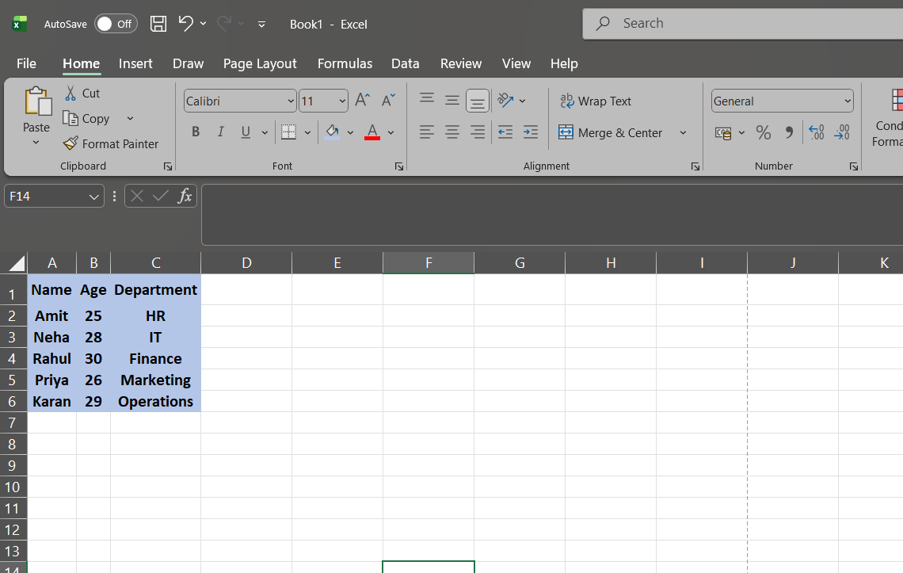

- Demonstrate how to insert and delete multiple rows and columns in Excel. (Provide screenshots before and after the changes.)
Ans :Demonstrating How to Insert and Delete Multiple Rows and Columns in Excel

A. Insert Multiple Rows and Columns
Insert Multiple Rows
Steps:
- Select the same number of rows you want to insert (e.g., select rows 3–5).
- Right-click on the selected rows.
- Click Insert.
- Excel inserts the same number of new rows above the selection.

Insert Multiple Columns
Steps:
- Select the same number of columns you want to insert (e.g., select columns B–D).
- Right-click on the selected columns.
- Click Insert.
- Excel inserts the new columns to the left of the selection.
Before & After (Insert)
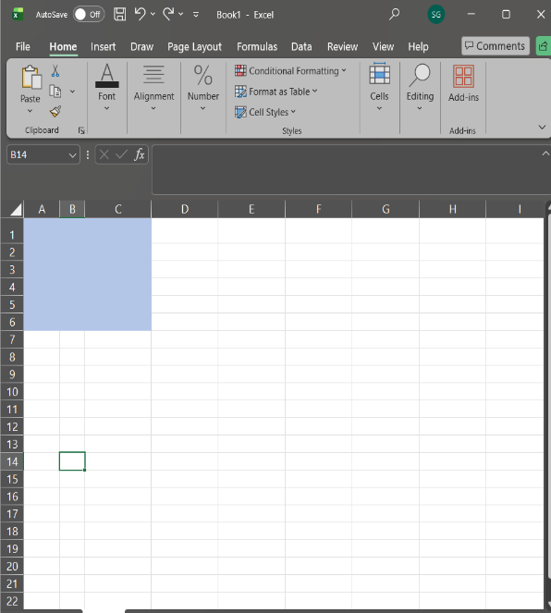
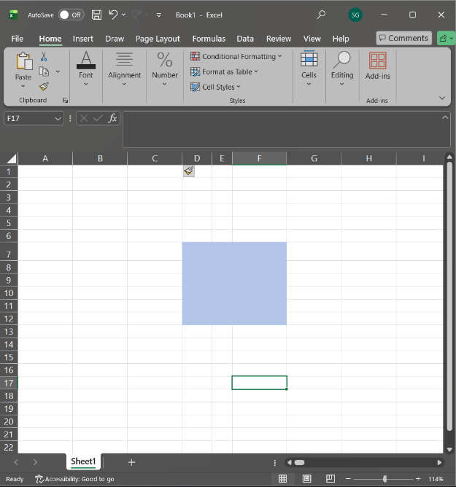
Before After

B. Delete Multiple Rows and Columns
Delete Multiple Rows
Steps:
- Select the rows you want to delete (e.g., rows 6–8).
- Right-click → Delete.
- Selected rows are removed and remaining rows shift up.
Delete Multiple Columns
Steps:
- Select the columns you want to delete (e.g., columns D–E).
- Right-click → Delete.
- Selected columns are removed and remaining columns shift left.
Before & After (Delete)
Before After

- Use Excel's 'Find and Replace' feature to update department names in a sample table. (Include a screenshot showing the replaced data.)
Ans : Using Excel’s Find and Replace to Update Department Names

Screen Shot (Before Replace)

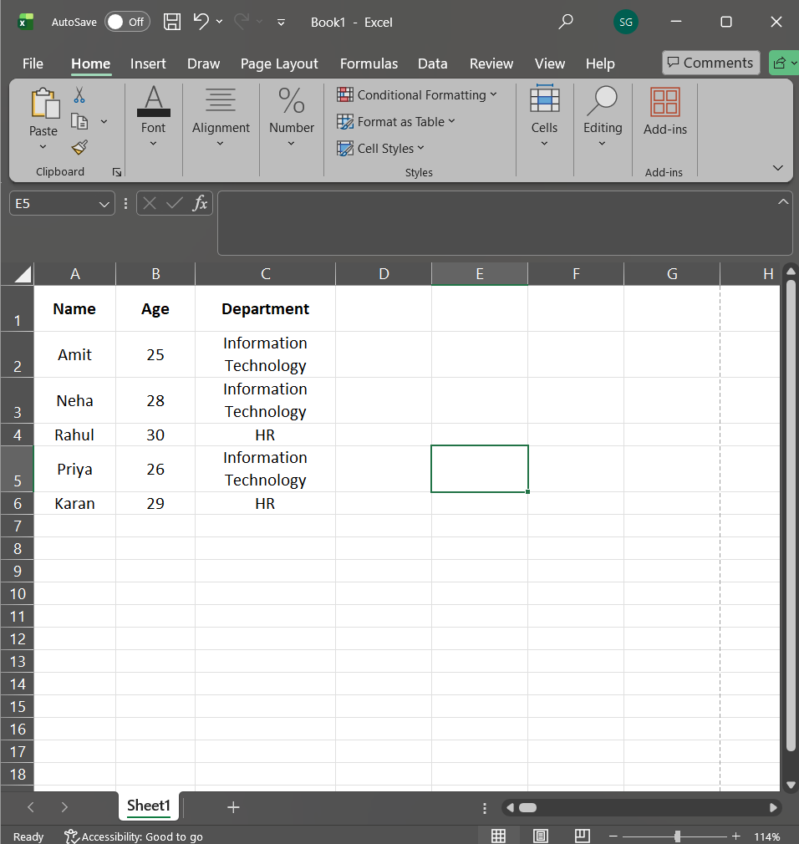

Steps to Use Find and Replace
- Select the Department column (or the entire table).
- Press Ctrl + H → Find and Replace dialog box opens.
- In Find what, type: IT
- In Replace with, type: Information Technology
- Click Replace All.
- Excel confirms how many replacements were made.

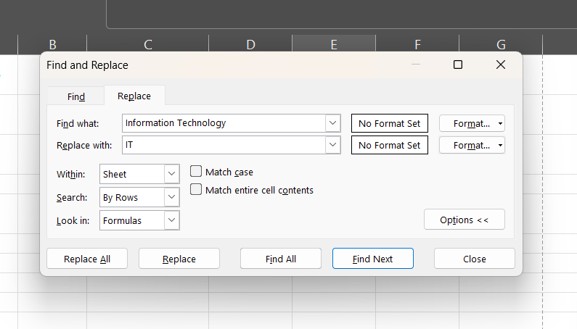

Screenshot Showing Replaced Data

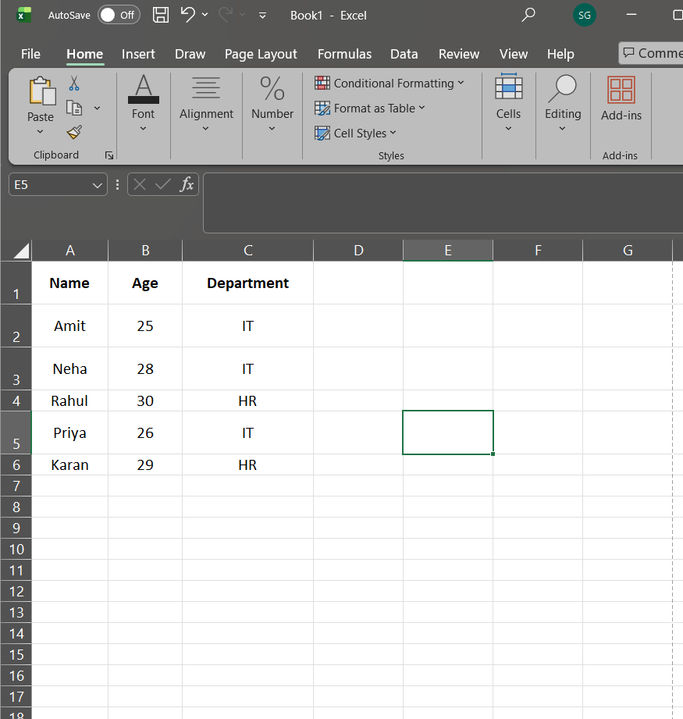

- Create a small numerical dataset and apply the following functions:
● AVERAGE
● MAX
● MIN
(Include a screenshot showing the formulas and their results.)
Ans :
Applying AVERAGE, MAX, and MIN Functions in Excel

Step 1: Create a Small Numerical Dataset
A (Values)
10
20
30
40
50

Step 2: Apply the Functions
Function | Formula Used | Result
AVERAGE | =AVERAGE(A1:A5) | 30
MAX | =MAX(A1:A5) | 50
MIN | =MIN(A1:A5) | 10

Explanation
- AVERAGE calculates the mean of the numbers.
- MAX returns the highest value in the range.
- MIN returns the lowest value in the range.

Screenshot Showing Formulas and Results

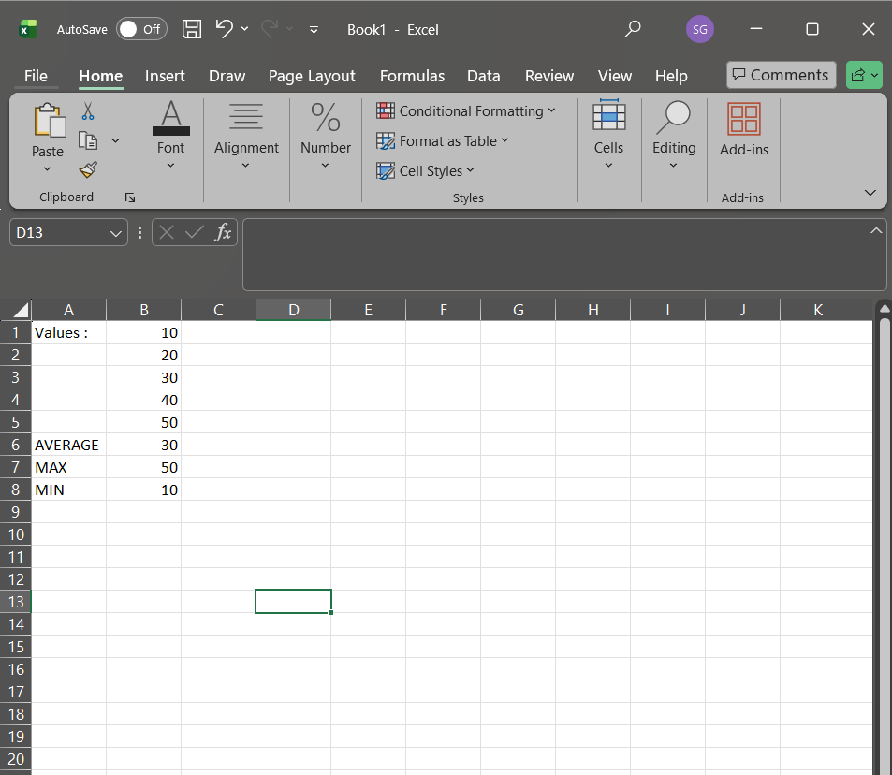

- You're working with a dataset that contains missing values. As a Data Scientist, explain how you'd detect and handle missing data using Excel. Mention tools like:
● Go To Special
● ISBLANK
● COUNTBLANK
(Include a screenshot showing how blanks are identified or processed.)
Ans :
Detecting and Handling Missing Data in Excel (as a Data Scientist)
When working with real-world datasets, missing values are common. In Excel, I would first detect missing data and then handle it appropriately using built-in tools and functions.

1. Detecting Missing Data
a) Go To Special
Purpose: Quickly identifies blank cells in a selected range.
Steps:
- Select the dataset.
- Press Ctrl + G → Click Special.
- Choose Blanks → Click OK.
- Excel highlights all blank cells.
Usefulness:
Fast visual identification of missing values in large datasets.

b) ISBLANK Function
Purpose: Checks whether a specific cell is empty.
Syntax:
=ISBLANK(A2)
Result:
- Returns TRUE if the cell is blank
- Returns FALSE if the cell has data
Application:
Used to flag missing values or create conditional logic (e.g., marking rows with missing data).

c) COUNTBLANK Function
Purpose: Counts the total number of blank cells in a range.
Syntax:
=COUNTBLANK(A2:A20)
Application:
Helps quantify how much data is missing before deciding how to handle it.

2. Handling Missing Data in Excel
After detecting missing values, I may:
- Delete rows with missing data (if very few and insignificant)
- Replace blanks using:
  - Mean/Median (for numerical data)
  - “Not Available” or “Unknown” (for categorical data)
- Use IF + ISBLANK to fill values conditionally
Example:
=IF(ISBLANK(A2), AVERAGE(A:A), A2)

Screenshot Showing Blank Identification / Processing

